September 2st, 2023

**Chair ICSMV 2023**

Dear ,

On behalf of the Organizing Committee of the XVI International Conference on Surface, Materials and Vacuum (XVI-ICSMV), I thank you for your important contribution as a Chair of the symposium.

The ICSMV is an annual international meeting that offers an exciting multidisciplinary setting and an interactive forum to discuss advances in materials, surfaces, interfaces, and vacuum science.

<https://site.smctsm.org.mx/2023-conference/>

The Conference will be a hybrid event from September 25-29th, 2023 in Zacatecas, Zacatecas, Mexico. We will have the face-to-face event with the required interaction, complemented by the robust and user-friendly internet platform WHOVA, in combination with ZOOM. We are sure that your participation will greatly contribute to the success of the congress.

Sincerely yours,

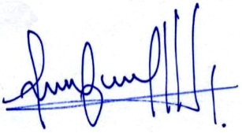

Mildred Quintana, Congress Chair